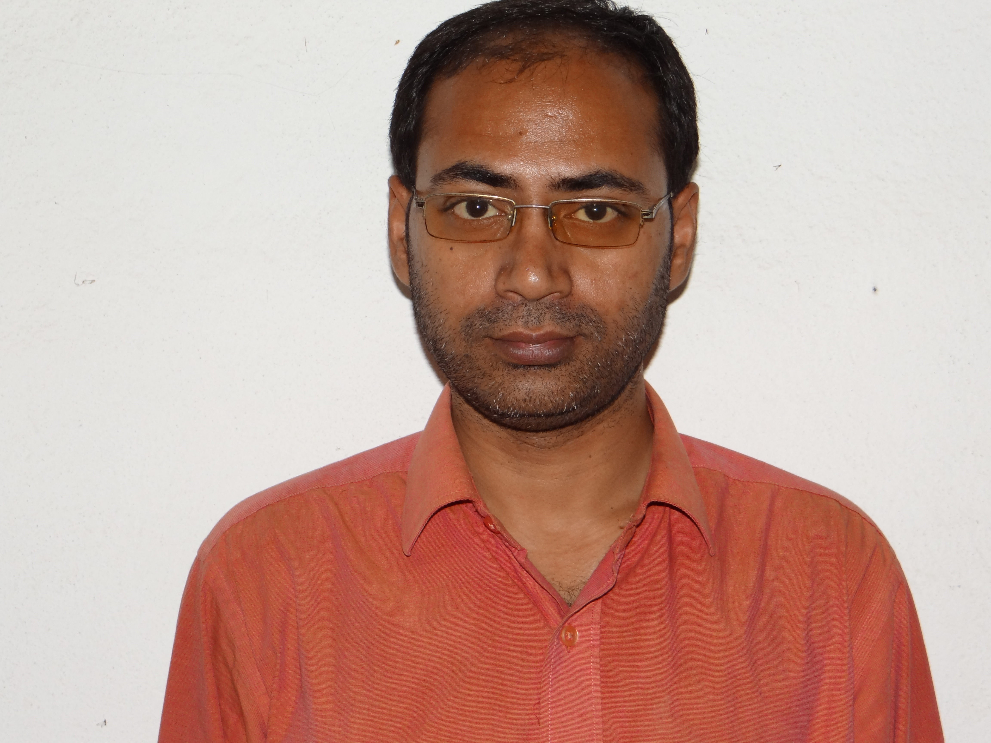PERSONAL PROFILE:

- Name: SUMANTRA CHANDA (MA in Ancient History)
- Designation: Assistant Professor
- Specialization: Ancient History
- Date of Birth: 13.03.1977
- Teaching Experience: 11+ years
- Courses Taught: Honours & General
- Subjects Taught: History
- Research Experience: Currently pursuing PhD in the Viswa-Bharati University
- Title of Thesis: Choice of Prota- and Antagonists in Bengali Historical Fiction, 1850-1950
- Date of Award of PhD: NA
- Future Plan of Research: Cultural Studies
- Publication: Nil
- Administrative Work: See Annexure - II
- Co-Curricular Activity: See Annexure - III
- Expert:
- Resource Person:
- Syllabus Planning:
- Examination Paper Setter:
- Visiting Member
- Extracurricular Activity: See Annexure - IV
- Organiser:
- Judge:
- Presiding Officer: Has essayed the role of Presiding Officer in the 2013 West Bengal State Panchayat Elections, 2013.
- Has Attended an Orientation Programme and a Refresher Course.

